Belton Iris Society
2013 Rhizome Sale
68 different named Tall Bearded iris rhizomes to choose from. (F) Fragrant, (H) Historic, (R) Rebloomer
Alcazar (H)
Alice Harding (F) (H)
Alpine Butterfly
Alpine Harmony
Ascent of Angels (F)
Auntie Claudia (F)
Autumn Circus (R)
Barbara Jean
Belton Beauty (H) ☺
Beth's Blessing (F)
Better Than Butter (F)
Betty Zimmerman
Blue Trill (F)
Bombay Eyes
Cardinal Rule
Carnival of Color (F)
Casino Cruiser (F)
Cheap Frills (F)
Christmas Present
Clarence
Class Clown (F) (R)
Clothed in Glory (F)
Coffee Trader (F)
Creative Urge (F)
Crystal Fountain
Doo Wop Memories (F)
Double Platinum (R)
Dragon King (F)
Eagles Spirit (F)**
Enter the Dragon
Fifty is Nifty (F)
Frilled to Bits (F)
Gallery (F)
Grain Exchange (F)
Grand Classic (F)
Happy Days (H)
Harvest of Memories (F) (R)
Hattie Emma
Ida Red (H)
Inspired (F)
Judy Nunn
La Scala
Midnight Passion
Naples (F)
Nouveau Riche
Out of the Dark (F)
Paul Clute (F)
Peggy Sue (F)
Plastic Money
Pursuit of Happiness (F)
Revision
Rich Girl (F)
Roper's Revenge (F)
School Marm's Blush
Sharp Dressed Man (F)
Show Your Colours (F)
Snapshot (F)
Snow Lion (F)
Softly Waiting (F)
Sorbonne
Sordid Lives
Sunset Plaza
Sunset Point (F)
Sweet Latte (F)
Ty Blue (F)
Up in Flames (F)
Valentine Romance (F)
Yuppy Puppy (F)
(**on last page)

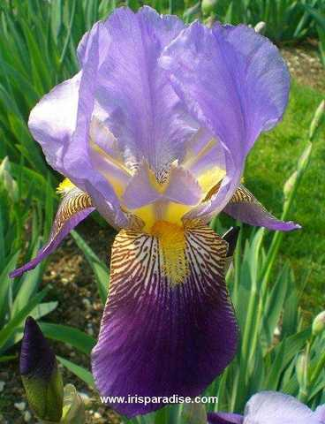
'Alcazar' (Vilmorin, R. 1910). Sdlg. Ddlg yr 1906. TB, , ML. Color Class-S3D. Color effect light hortense violet, velvety pansy-violet bicolor; S. light mauve or hortense violet, shaded deeper in recesses of creped portions.; F. deep velvety pansy violet, bronzed and veined on wide outer haft and becoming olive-yellow along the dense, showy beard. A large well-balanced flower of extra substance, firm texture, and good fragrance. The exceptionally tall, widely branched flowering stalks are freely produced and well supported by excellent dark foliage of open growth. This is a distinct variety, and one of the best ten as a specimen plant. Rating 89. (Historic)
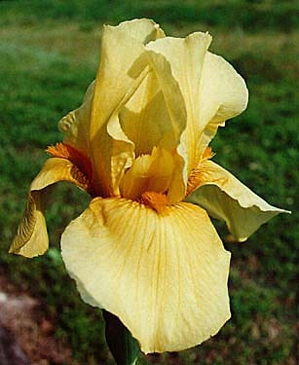
'Alice Harding' (Ferdinand Cayeux, R. 1933). TB, Mid bloom season. Color Class-Y4L, Award of Merit AIS 1927; French Dykes Memorial Medal 1933; Harding Prize 1933. "Medium yellow. Closed standards and semi-flaring falls of medium yellow; bright orange beard. Strongly fragrant, large flowers on extra-good stalks. (Historic)
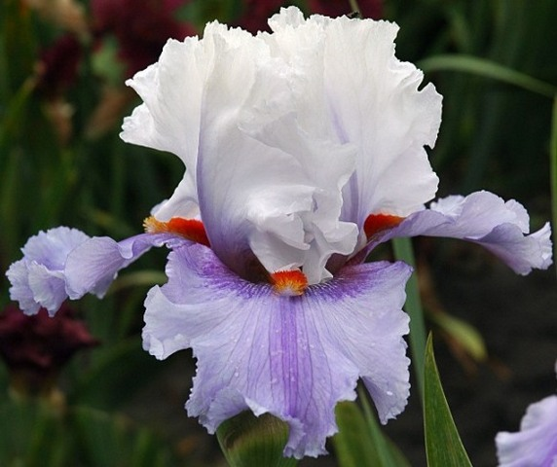
'Alpine Butterfly' (Barry Blyth, R. 2008). Sdlg. P22-1. TB, 40" (102 cm), ML. S. white, soft violet midrib and flush; F. soft pastel lavender, violet area each side of beard, flared; beards white tipped bright red.
Hybridizer's Comment: Standards are white with a soft violet flush at the midribs. Fails are soft pastel lavender and each side of the beard is an area of mid violet like thurnbprints. Beards are bright tangerine-red over white. Flowers have horizontally flaring falls that are lightly ruffled. Huge bloorns on show sterns. Makes big plants.
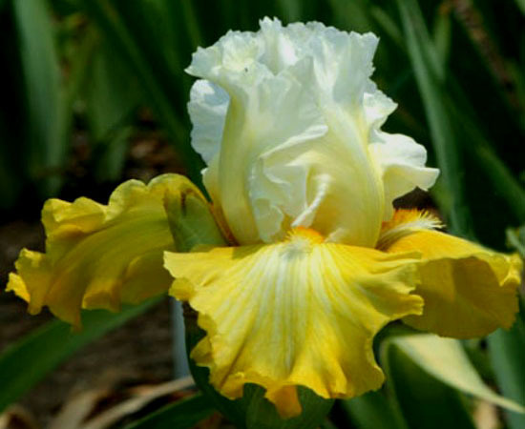
'Alpine Harmony' (Barry Blyth, registered 2007). Seedling N245-2. TB, height 36" (91 cm), early to mid bloom season. Standards white, slightly lemon at base of midrib; falls bright lemon-yellow, small lighter creamy yellow area below beard; beards white tipped orange; ruffled.
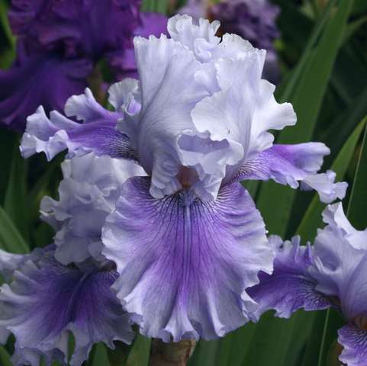
'Ascent of Angels' (Mike Bernard, R. 1995). Sdlg. T120A. TB, 36" (91 cm), M. S. wistaria blue (RHS 92D), midrib deeper; F. wistaria blue washed violet (87A); beards light lavender, gold deep in throat; heavily ruffled; pronounced sweet fragrance.

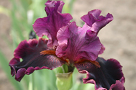
'Auntie Claudia' (Tom Burseen, R. 2009). Seedling 06-14A. TB, 36" (91 cm), Early-mid bloom season. Standards light beetroot purple (RHS 71C); style arms same, gold wash; falls dark beetroot purple (71A), blackish sheen, edges washed light beetroot purple; beards burnt orange (169B); ruffled; slight musky fragrance.
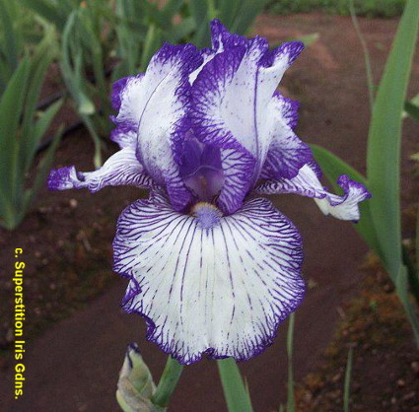
'Autumn Circus' (Ben Hager, R. 1990). Seedling RE4889StpPc. TB, height 34" (86 cm), Early bloom season & Reblooms (Sept-Oct/CA). Standards white, lightly peppered blue violet to solid edge; style arms deep violet; falls white, bold lines radiating from white beard, blue violet plicata edge.
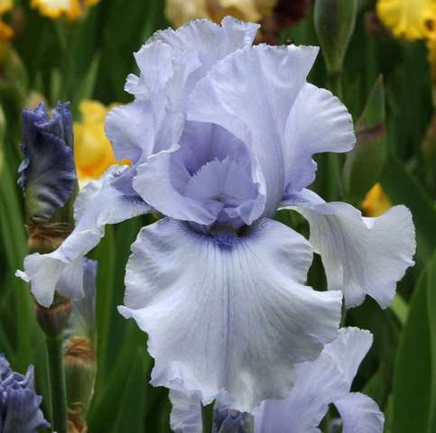
'Barbara Jean' (Ronald Mullin, R. 2004) Sdlg. V26A. TB, 35" (89 cm), EM. Silvery medium blue self, F. have tiny magenta crescent at base of beard; beards inky blue-black. Honorable Mention 2007; President's Cup 2007; Award of Merit 2009.
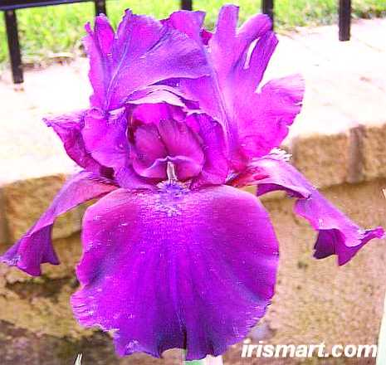
'Belton Beauty' (Frey, R. 1957). Sdlg. 54-1. TB, 38" (97 cm), EM. Color Class-V1M, S. medium violet, F. same with white haft area. (Historic), Hybridized in Belton, Texas
/K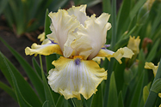
'Beth's Blessings' (Tom Burseen, R. 2009). Seedling 05-582A. TB, 35” (89 cm), Mid-late bloom season. Standards pale lavender blue-white, fine yellow gold edges; style arms same as Standards, more prominent yellowgold edging; falls white washed amber yellow at edges, yellow ochre shoulders; white frosted beards gold, blue at end; flared, looping ruffles; slight sweet fragrance.
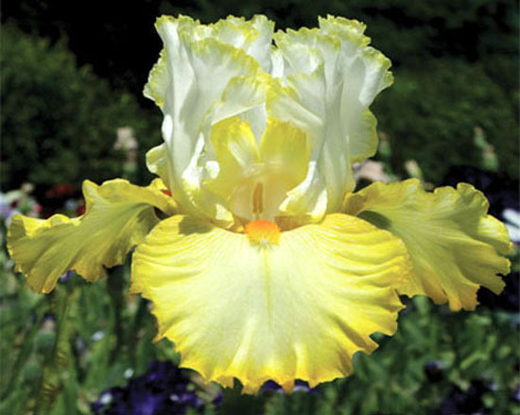
'Better Than Butter' (Paul Black, R. 2010) Sdlg. N36A. TB, 41" (104 cm), EML. S. white, narrow bright yellow bands; style arms white, yellow crests; F. light medium yellow darkening toward edge, narrow muted gold band; beards pale yellow base tipped light tangerine; slight musky fragrance. HM 2012.
Hybridizer's Comment: This buttery confection will make your mouth water. Ruffled standards are bright white edged glittering bright yellow. White and yellow styles arch above round, flared falls of light yellow blending darker toward edges that are narrowly banded darker gold. Soft tangerine beards add a lovely contrast. Three branches and rebranch provide 8-9 buds. Clumps are very bright and showy. You can't ignore something that is Better than Butter! Thank you to Kathy Chilton for the nice name.
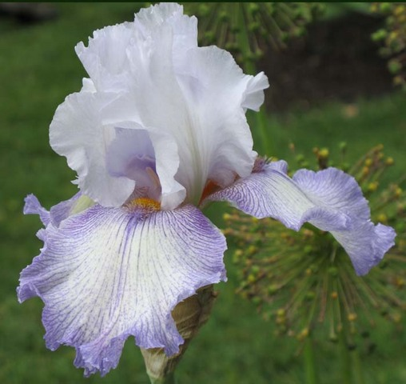
'Betty Zimmerman' (Hooker Nichols, R. 2006) Sdlg. 9509S. TB, 36" (91 cm), ML. Ruffled white ground violet plicata; beards tangerine.
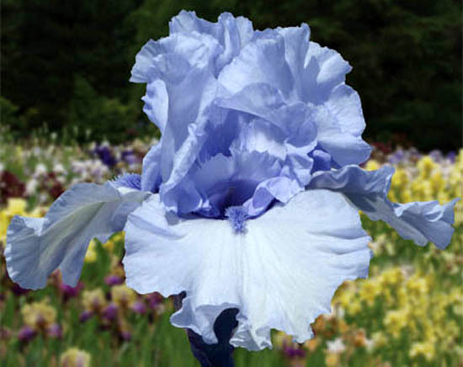
'Blue Trill' (Paul Black, R. 2010) Sdlg. N193B. TB, 39" (99 cm), EML. S. and style arms medium sky blue; F. pale sky blue; beards medium blue; pronounced sweet fragrance.
Hybridizer's Comments: Over the whisper of a soft breeze comes a sprightly trill, a Blue Trill. Medium blue standards and styles give way to paler blue-white falls. The high note is echoed by darker, plush blue beards. Three well-spaced branches and spur produce 10-11 beautifully formed flowers. Clean growth and purple based foliage assure the music will play on into the summer. Blue Trill crossed to a sibling gave about 75 percent purple based foliage seedlings that all show robust growth. It should be a good parent for those working for whites with blue beards. Maybe there will be a step forward in the sib cross that is to bloom this spring.
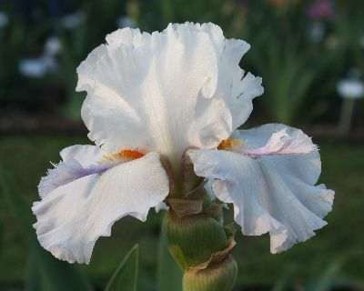
'Bombay Eyes' (Hooker Nichols, R. 2007). TB, 36" (91 cm), EM. S. ice blue-lavender; style arms ice lavender; F. lighter, chartreuse veining, sapphire triangle surrounding beard; beards yellow and powder blue, very short horns; ruffled, sculpted.
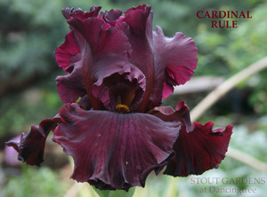
'Cardinal Rule' (Joseph Ghio, R. 2010) Sdlg. 05-53G5. TB, 36" (91 cm), ML S. and style arms claret rosy red; F. same, hint of violet around muted bronze beard.
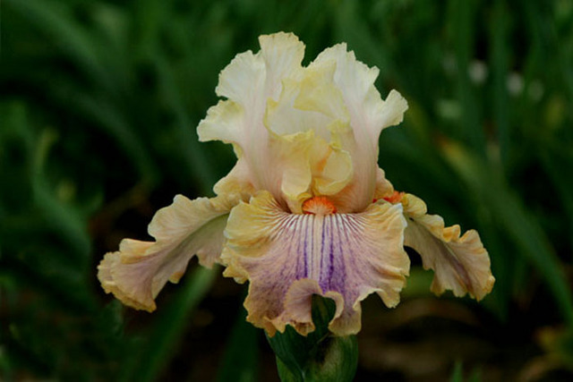
'Carnival Of Color' (Paul Black, R. 2009). Seedling M86BB. TB, 35” (89 cm), Early-mid bloom season. Standards cream base blushed metallic pink over center blending paler toward edge to darker tan-butter margins, fine darker pink veins shot outward; style arms pale cream-white, medium peach rib, edge and crests; falls pale cream-white center, haft heavily veined tan brown to wide gold peach haft margin extending . way down, medium metallic peach sheen over center veined and washed dark violet; beards minimal white tipped medium orange; ruffled; pronounced sweet fragrance. Honorable Mention 2011.
Hybridizer's Comment: Carnival of Color brings a very lively splash of color to your garden. Warm white standards are blushed metallic pink at their bases, blending upward and rimmed with tan gold lace. Heavily ruffled, falls are white across hafts and veined plum. Golden peach outer haft narrows as it descends to encircle mauve pink central falls that are lined dark purple and washed mid purple. Haft edges are rimmed white changing to gilt gold lace as it moves around the falls. Beards are bright orange. Foliage is healthy blue green. Stalks have 3 branches plus a basal branch and 9-11 buds.
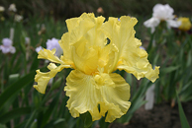
'Casino Cruiser' (Tom Burseen, registered 2007). Seedling 02-199A. TB, height 36" (91 cm), early season bloom. Standards blended light chrome yellow (RHS 15C) and buttercup yellow (15A); style arms buttercup yellow; falls same as standards, maize yellow hafts, texture veined; beards yellow gold, light chrome yellow spoons; ruffled; sweet fragrance. Honorable Mention 2011.
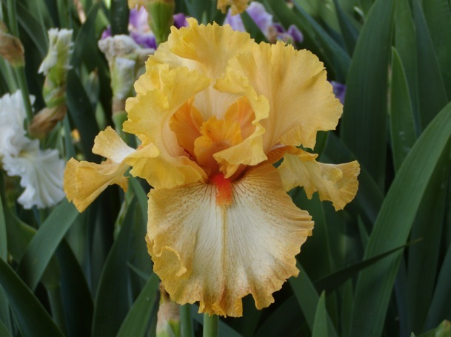
'Cheap Frills' (Paul Black, R. 2009). Seedling N19A. TB, 38” (97 cm), Early-mid-late bloom season. Standards buff peach, darker toward edge; style arms apricot peach, darker crests; falls white, light cinnamon plicata washed haft and 1/2" plicata band washed paler 1" inside band, medium brassy-green center stripe running 3/4 of way down; beards dark red-orange; ruffled, laced; slight sweet fragrance. Honorable Mention 2011.
Hybridizer's Comment: The only thing cheap about this heavily ruffled and laced beauty is the price. This excitingly different plicata has darker buff peach styles that peer from between light buff peach standards. White falls give way to heavily laced subtle cinnamon peach plicata washed and dotted margins and hafts. Zingy red orange beards terminate in greenish stripes extending 3/4 way down falls. Strong, vigorous growth produces exceptional show stalks with 3-4 branches and 10-11 buds. Barry Blyth said it gave a splendid performance as a guest in Australia. Expect exciting seedlings in a wide array of colors and patterns.
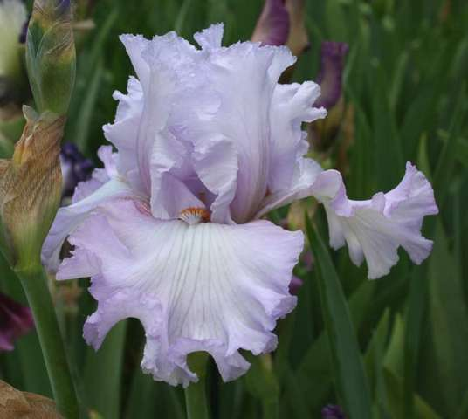
'Christmas Present' (Joseph Ghio, R. 2006). Seedling 01-76G2. TB, 34" (86 cm), Mid to late bloom season. Blue orchid self, falls lighter in center with greenish cast; beards tangerine, orchid at end. Honorable Mention 2009; Award of Merit 2011.
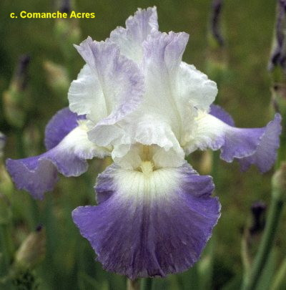
'Clarence' (Lloyd Zurbrigg, R. 1990). Sdlg. ZZZ. TB, 35" (89 cm), M & RE (Aug/ NC & VA). S. white, tinted violet at top; F. light blue violet, white center and hafts; cream beard; sweet fragrance. Parentage unknown. Avonbank 1991. Honorable Mention 1995; Award of Merit 1997; Wister Medal 2000.
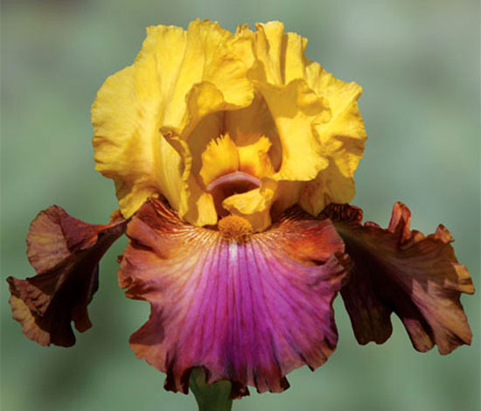
'Class Clown' (Paul Black, R. 2010) Sdlg. M101AA. TB, 41" (104 cm), ML S. bright medium gold; style arms medium gold; F. wide mahogany to amber hafts becoming darker plum bands around lower 1/2, fuchsia center wedge; beards dark old gold; slight musky fragrance.
Hybridizer's comment: 'Class Clown' is bright, cheery and sure to put a smile on your face with what looks like a big clown grin spread over the falls. Standards and styles are bright gold. Exuberantly colored falls have mahogany to amber hafts becoming darker plum bands along outer edges. A big fuchsia grin spreads across the centers. Plush old gold beards complete this fun ensemble. Strong growth yields show stalks with 3 branches and spur and about 8-9 buds. While it hasn't rebloomed in Salem, the genetics are there for it to do so in warmer climates. It is being used to produce colorful, well-formed rebloomers.
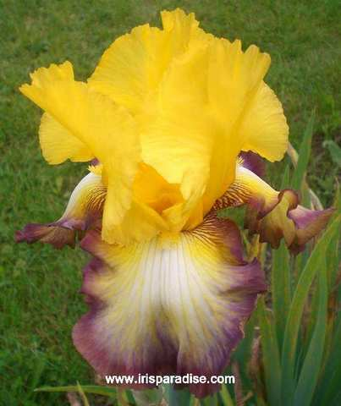
'Clothed In Glory' (Frederick Kerr, R. 2004). Sdlg. 99-088C. TB, 36" (91 cm), M. S. and style arms dark yellow; F. yellow, wide darker yellow hafts, 3/4" dark brownish-red band around edge, white area around beards, expanding as flower ages; beards white tipped gold; slight sweet fragrance.
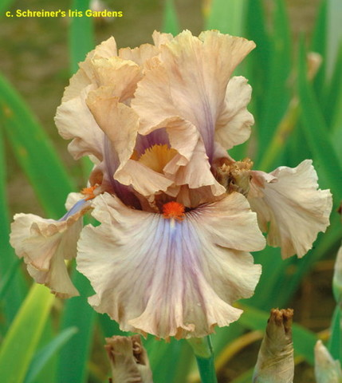
'Coffee Trader' (Barry Blyth, R. 2004). Sdlg. K65-5. TB, 38" (96 cm), ML. S. milky coffee tones, some soft violet flushing at midrib; F. milky coffee, large violet outpouring below beards; bright tangerine orange beards; slight sweet fragrance.
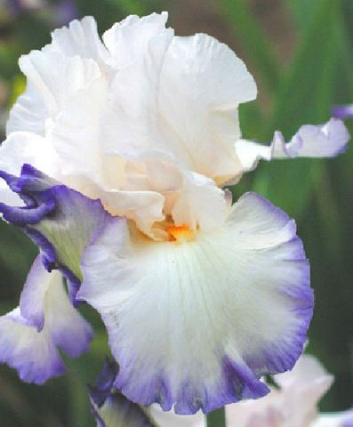
'Creative Urge' (Frederick Kerr, R. 2008). Sdlg. 03-107 BEST. TB, 38" (97 cm), M. S. white, sometimes edged tan; style arms white tipped gold; F. white, 1/4" to 1/2" blue edge which diffuses toward center, golden brown lines at haft; beards salmon orange; slight sweet fragrance.
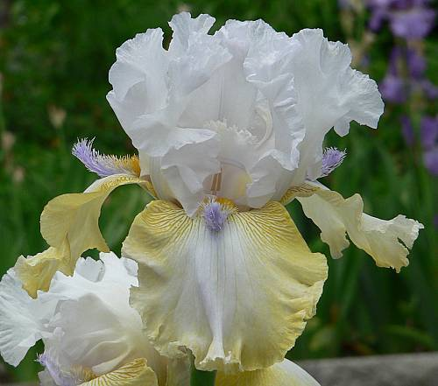
'Crystal Fountain' (Vincent Christopherson, R. 2007). Sdlg. A5-101-AH. TB, 37" (94 cm), M. S. and style arms white, faint blue cast; F. medium yellow band and haft rays blending to cream in center; beards yellow, light blue horns and end.
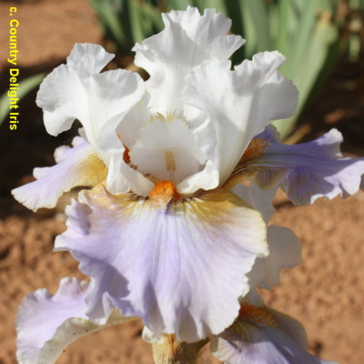
'Do Wop Memories' (Tom Burseen, R. 2008) Sdlg. 02-397A. TB, 35" (89 cm), Midseason late bloom. Standards white; style arms same, slight yellow feathered edges; Falls white washed violet blue; beards burnt tangerine; round, ruffled; pronounced spicy fragrance.
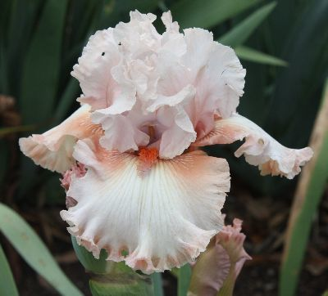
'Double Platinum' (Joseph Ghio, R. 2011) Sdlg. 06-72-03. TB, 36 (91 cm), Midseason late bloom and rebloom. Standards light shell pink, deeper pink midrib; Falls pearl pink, biscuit-pink shoulders to narrow biscuit-pink edge; beards tangerine.
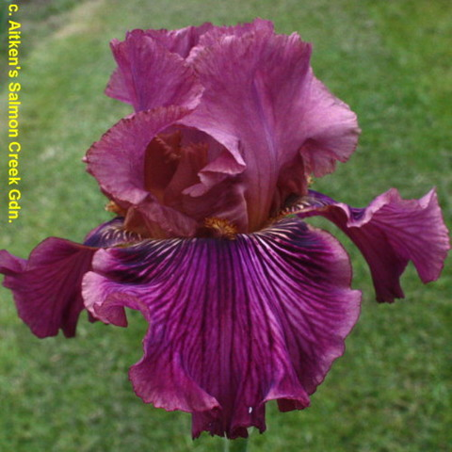
'Dragon King'(Richard Tasco, R. 2011) Sdlg. 06-TB-15-31. TB, 37 (94 cm), Early midseason bloom. Standards magenta mauve, slightly darker toward top of midrib, tops slightly laced; style arms lemon amber, brown along midrib, brown fringed crest; Falls red orchid ground prominently veined dark burgundy-black, slight magenta-mauve rim, , white and yellow veins on shoulders and around dark burnt-orange beards; lightly ruffled, medium purple base foliage; slight fragrance.
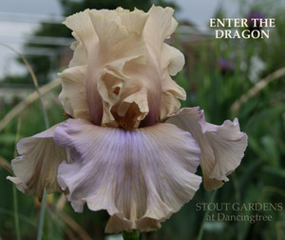
'Enter The Dragon' (Barry Blyth, R. 2008). Sdlg. O256-A. TB, 34" (86 cm), EM. S. beige champagne; F. same shot with lavender wash; beards brown-bronze-tangerine.
Hybridizer's Comment: A standout for us from its maiden bloom, mainly because of its form and super beards. Standards are beige champagne and the falls are the same, shot with lavender, just like shot silk. Beards are striking brown-bronze over tangerine. Everyone loves this unique iris. Good branching. Quite Fertile.
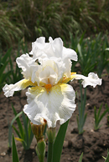
'Fifty Is Nifty' (Tom Burseen, registered 2006). Seedling 02-162A. TB, height 37" (94 cm), early season bloom. White self, gold burst hafts; beards tangerine orange; flared, ruffled; musky fragrance.
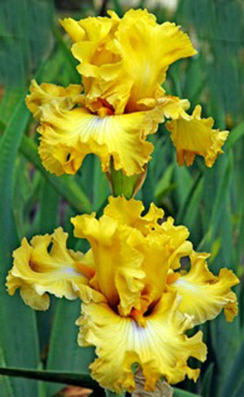
'Frilled To Bits' (Barry Blyth, R. 2009). Seedling O256-C. TB, 40" (102 cm), Mid bloom season. Standards vivid lemon yellow; falls same, whitish area with bluish haze, extremely ruffled and flared; beards mustard; slight sweet fragrance. .
Hybridizer's Comment: We think it is one of the loveliest iris we have raised. It's delicious! It is citrus yellow, the colour of lemon skins, with a small white area around the beards shading to soft blue just below the beards. Beards are vivid mustard. Flower form is exceptional as the photo shows. Ruffled, fluted and horizontally flaring. It has show stems and displays blooms beautifully. Plants are not large but give huge flower stems. Slight sweet perfume.. An exciting cross producing such a variation. Fertile and a good parent.
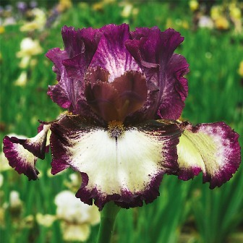
'Gallery' (Thomas Johnson, R. 2005). Sdlg. T135B. TB, 41" (104 cm), E. S. nearly solid dark mulberry-violet plicata marking over white ground; style arms buff, mulberry center and crest; F. creamy white ground, near 1/2" deep mulberry plic band, deeper at haft; beards mulberry at end, rust in middle, tangerine in throat, hairs tangerine base tipped white; slight fragrance.
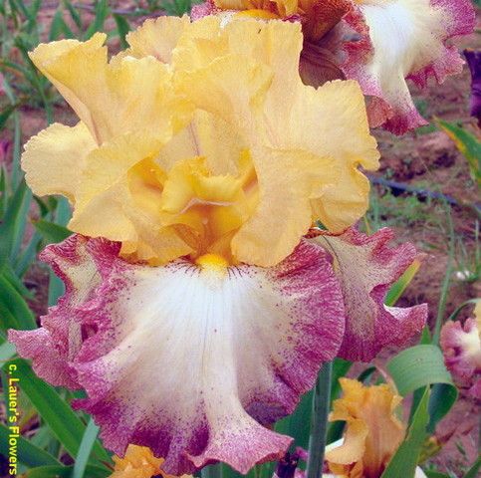
'Grain Exchange' (Joyce Ragle, R. 2006). Sdlg. 00-29PCKCOP-1. TB, 38" (97 cm), EM. S. bright old gold (RHS 162A); style arms same, slight pale brown tints on sides, laced crests; F. white center, pale barium yellow (10D) overall except for 1/2" stitched and dotted edge of red-brown (176C); beards buttercup yellow (16C); very ruffled, slightly laced; pronounced sweet fragrance. HM 2009.
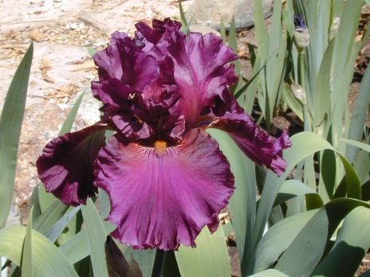
'Grand Classic'. (Richard Tasco, R. 2007). Seedling 00-TB-14-06. TB, height 40" (102 cm), Mid bloom season. Standards black cherry, darker toward edges; style arms burnt gold, wide black cherry midrib and fringed crest; violet halo on underside of stigmatic lip; falls same as standards, short narrow plum-violet flash near end of beard; beards golden brown, tangerine in throat, few hairs tipped violet at end; ruffled; sweet fragrance.
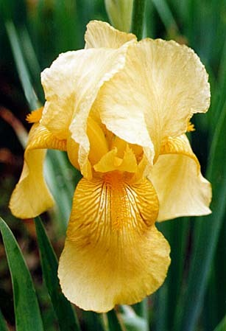
'Happy Days' (Sidney B. Mitchell, 1934). TB, Early/Midseason bloom. Color Code Y4M. An imminse clear yellow with an unusual glistening finish. Standards pinard yellow; falls a shade deeper, the beard a rich orange yellow, many large flowers which do not fleck or fade. (Historic)
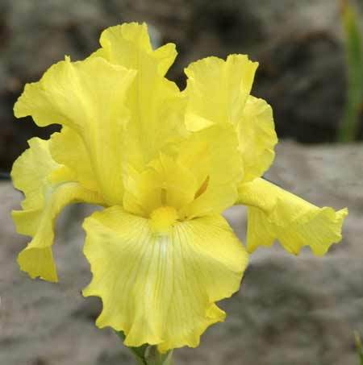
'Harvest of Memories' (Lloyd Zurbrigg, R. 1984). Sdlg. R 87DY. TB, 38" (97 cm). Midseason bloom and rebloom. (Oct in VA). Dresden yellow (HCC 640/1); yellow beard; slight sweet fragrance.
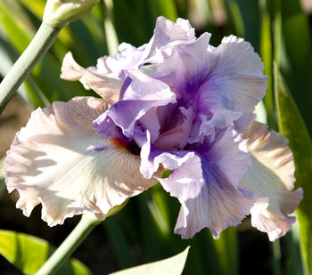
'Hattie Emma' (Tom Burseen, R. 2008). Sdlg. 04-43A. TB, 36" (91 cm), ML. S. and style arms violet blue (RHS 92C), darker bases; F. cream buff, darker edges; beards white tipped tangerine, hairy light violet-blue horns; ruffled.
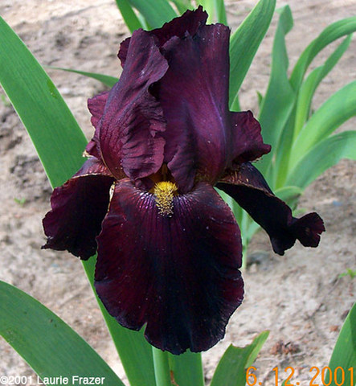
'Ida Red' (B. Clark, R. 1978). TB, 36" (91 cm), EM. Deep red-wine; gold-bronze beard. (Historic)
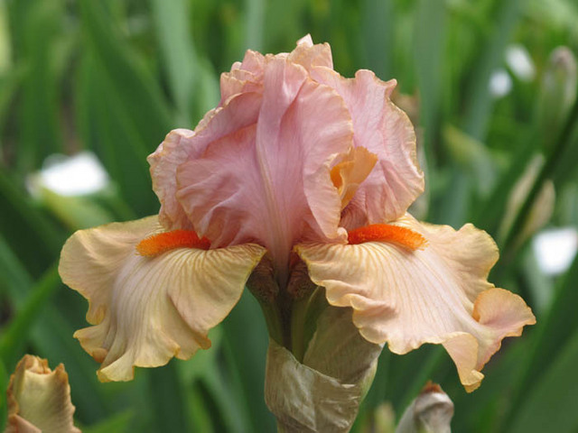
'Inspired' (Paul Black, R. 2009). Seedling M166E. TB, 34” (86 cm), Early-mid bloom season. Standards medium dusky-pink, crystalline apricot gilt rim; style arms medium peach; falls apricot tan, darker amber texture veins, darker apricot-tan gilt rim; beards bright, fully saturated red-orange; small flowered; pronounced spicy fragrance. HM 2012.
Hybridizer's Comment: 'Inspired'demonstrates the versatility Dolce possesses in creating lovely smaller flowered tall bearded irises. Glittering apricot gilt rims encircle medium dusky rose standards. Medium apricot peach styles lead your eye to mid apricot tan falls incised with darker amber texture veins and rimmed apricot gilt. Bushy red orange beards set the falls ablaze. Rapid growth creates massive clumps filled with well branched and budded show stalks. Inspired makes a compelling case that bigger isn't necessarily better. Become Inspired!
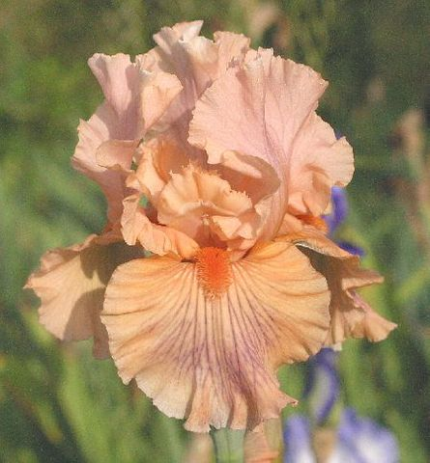
'Judy Nunn' (Frederick Kerr, R. 2009). Seedling 03-061A. TB, 35" (89 cm). Midseason bloom. Standards pink; style arms light orange; Falls pink, orange influence at haft and toward lighter edge, medium violet veining from the beard to within 1/2" of edge; beards tangerine coral. Honorable Mention 2012.
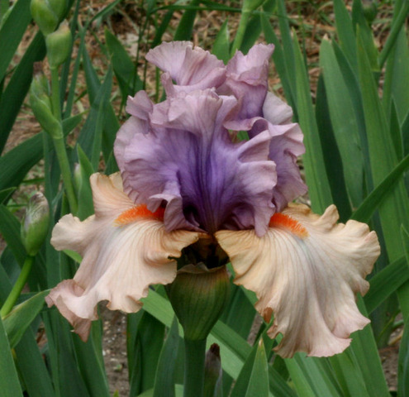
'La Scala' (Keith Keppel, R. 2007). Seedling 01-98A. TB, 37" (94 cm), Early thru mid bloom season. Standards greyed pinkish lavender (M&P 43-D-3) blending to violet orchid (43-F-8) center; style arms creamy peach (9-AB-4), midrib lavender; falls pale pink (1-AB-8), center lighter and creamier, hafts flushed creamy peach (10-B-4); beards white tipped flame (1-L-12). HM 2010, AM 2012.
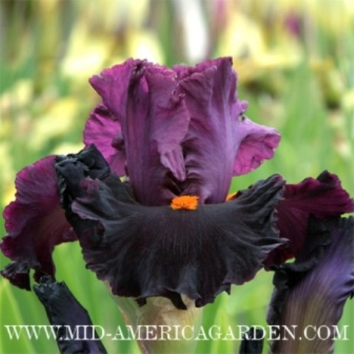
'Midnight Passion' (Keith Keppel, R. 2007). Sdlg. 99-120C. TB, 32" (81 cm), ML. S. silky smoked red purple (between M&P 47-H-4 and 48-H-3); style arms mello mauve (45-F-1) to crushed violets (45-G-5); F. velvety shiny red-black; beards tomato red (3-I-12). Honorable Mention 2011.
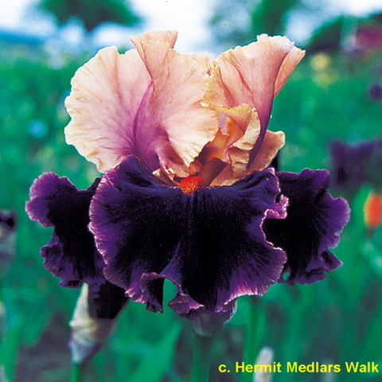
'Naples' (Thomas Johnson, registered 2000). Seedling O3AA. TB, height 33" (84 cm), early to mid season bloomer. Standards mauve buff, purple midrib infusion, gilt rim; style arms peach apricot; falls velvety dark purple with lighter edge, white to salmon area veined purple around dark orange beard; ruffled; foliage base and stalks light purple; slight sweet fragrance.
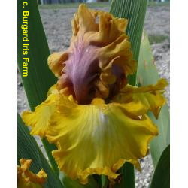
'Nouveau Riche' (Keith Keppel, R. 2007). Seedling. 99-93A. TB, 40" (102 cm), Very early thru early bloom season. Standards lime yellow (M&P 11-L-5), central area rosy mauve (53-F-5); style arms light chrome yellow (10-L-4) crests; falls dandelion (9-L-4), lighter (9-L-3) toward center, small cream glint; beards yellow ochre (11-L-7), goldenrod (10-L-5) at end. HM 2010, AM 2012.
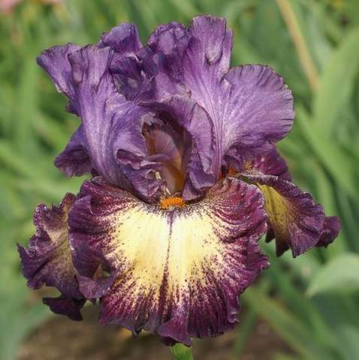
'Out Of The Dark' (Paul Black, R. 2007). Sdlg. L81B. TB, 40" (102 cm), ML. S. light buff washed medium purple overall, paler around midrib; style arms purple; F. buff, wide purple plicata band, dotted and sanded inside band; markings heavier over haft, sanded luminata-plicata patch around beard, sanded line down center; beards white tipped burnt orange; ruffled; slight spicy fragrance.
Hybridizer's Comment: This introduction is from work started several generations ago using Pretty Pansy, an old Sass luminata, to create a line of strong pink ground plicatas. While OUT OF THE DARK isn't pink, it does have apricot-buff ground and is one step closer to my goal in that it is a strong grower with plenty of tangerine genes in its heritage. The apricot-buff ground color is almost completely washed purple in the standards. The falls have wide sanded and dotted plicata bands and center stripes of dark beetroot. Beards are smoldering burnt orange and are surrounded by white lumi-plic patches sanded dark wine. OUT OF THE DARK is quite tall for this type plicata and blooms later, thus avoiding damage from late frosts.
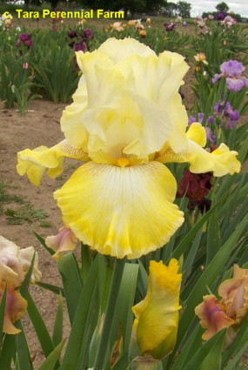
'Paul Clute' (Richard Ernst, registered 2006) Seedling W112-31. TB, height 38" (97 cm), mid to late season bloom. Standards and style arms white; falls yellow, white pencil rim, brown tick marks at orange yellow beard; slight sweet fragrance.
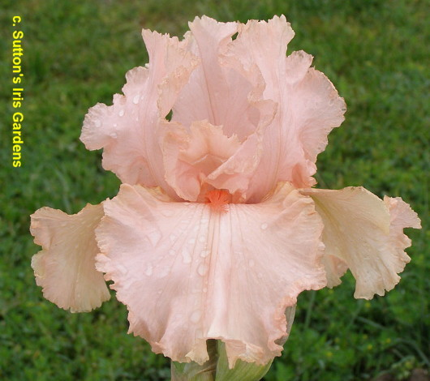
'Peggy Sue' (Larry Lauer, R. 2006). Sdlg. 2012-21R. TB, 34" (86 cm), EML & RE. S. dawn pink (RHS 49A); style arms venetian pink (49B); F. orient pink (36B); beards mandarin red (40B); lightly ruffled; pronounced sweet fragrance. HM 2008, AM 2010.
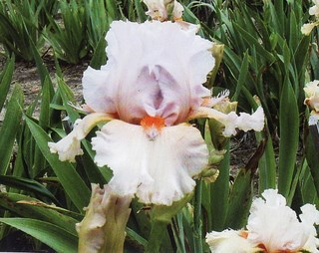
'Plastic Money' (Tom Burseen, registered 2007). Seedling 03-47A. TB, height 36" (91 cm), mid season bloom. Standards and style arms light sea lavender-violet (RHS 85D); falls creamy amber, light amber hafts; beards carrot red, fat, fuzzy, feathered sea lavender-violet horns; ruffled, serrated.
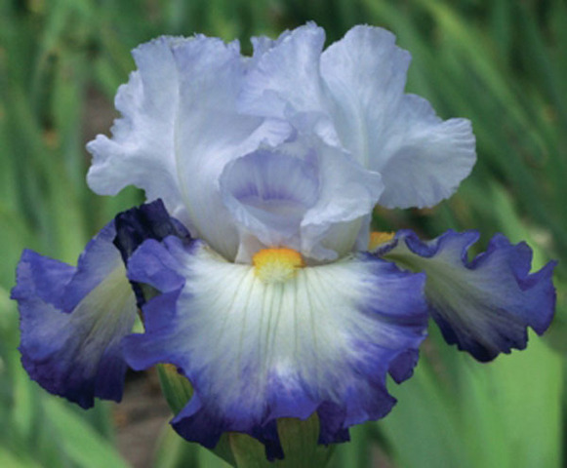
'Pursuit of Happiness' (Thomas Johnson, R. 2007). Sdlg. Tw43C. TB, 36" (91 cm), M. S. blue white; style arms same, crests touched blue lavender; F. medium lavender-blue, large white central wash around deep lemon-orange beard; sweet fragrance.
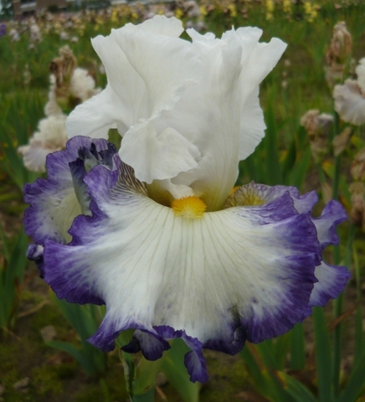
'Revision' (Keith Keppel, R 2010) Sdlg. 04-93B. TB, 39" (99 cm), Early, midseason, late bloom. Standards white; style arms white, pale blue lip; Falls white, solid 3/8" columbine blue (M&P 42-GH-10) band; beards bright golden yellow (darker than 9-L-6).
Hybridizer's Comment: We chose its sib Brilliant Idea for the outrageous beard, but as time goes by we have revised our thinking: better branching and more precise, sharper pattern makes Revision the technically better iris. Pure white standards, white falls with distinctive 3/8" columbine blue band, plus very prominent (but flot outrageous) golden yellow beard. Standards upright and touching, fails lightly flared. Terminal and three (or four) well-spaced branches carry seven to fine buds. Best seedling in show, Salem 2010.
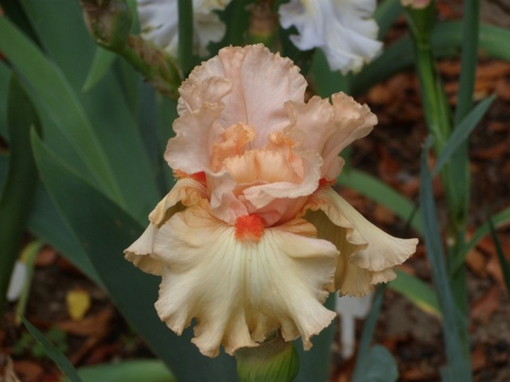
‘Rich Girl’ (Lesley Painter, R. 2009). Sdlg. L03-25E. TB, 36” (91 cm), Mid bloom season. Standards peach pink; style arms peach; falls peach orange, lighter below melon orange beards; ruffled, lightly laced; slight citrus fragrance.
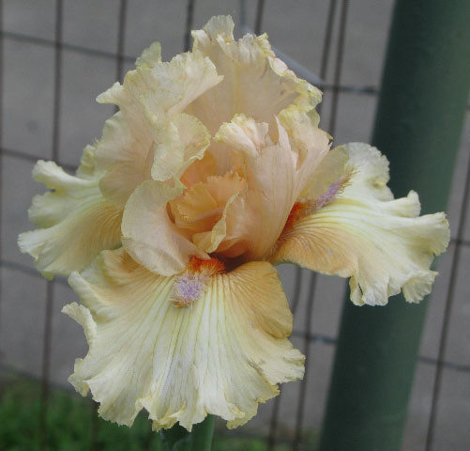
'Roper's Revenge' (Tom Burseen, registered 2007). Seedling 03-108B. TB, height 37" (94 cm), early to mid season bloom. Standards light peach (RHS 29D); style arms darker (29B); falls cream blended light peach, hafts brushed apricot buff (170C); beards cream tipped tangerine, light peach flounces; ruffled, laced; spicy fragrance.

Unfortunately,
photo could not be obtained.

'School Marm's Blush' (Hooker Nichols, R. 2007). TB, 36" (91 cm), ML. S. pale creamy coral; F. same, deeper coral hafts; beards fat neon orange; ruffled and laced.
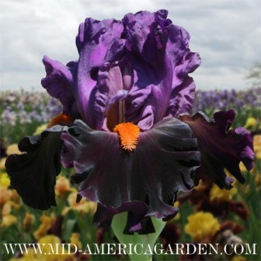
'Sharp Dressed Man' (Thomas Johnson, R. 2010) Sdlg. Tz58A. TB, 36" (91 cm), M. S. iridescent medium purple; F. purple black, slightly lighter rim, velvety, elegantly ruffled; beards shocking bright orange; sweet fragrance. HM 2012.
Hybridizer's Comment: He's tall, dark and handsome and draws the eye of anyone walking by. Only the finest clothes will do for this 'Sharp Dressed Man'. Standards are iridescent mid purple. Elegantly ruffled purple black falls have a velvety texture and slightly lighter rim. Only someone so confident could get by with such an outrageous orange tie. Show stalks with 3-4 branches and 10-12 buds help insure a superior garden performance. Robust, healthy growth. Colors are exceptionally clear.
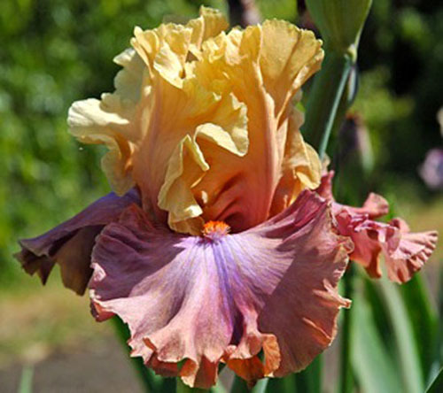
'Show Your Colours' (Barry Blyth, R. 2009). Sdlg. Q15-1. TB, 40” (102 cm), M. Standards honey apricot, slight rose infusion at midrib; falls soft rosy-violet, deep violet “V” blaze from tangerine beard to edge; pronounced sweet fragrance.
Hybridizer's Comment: Standards are honey apricot and falls are a very soft rosy-violet with a deeper violet "v' shaped blaze below the beard extending down to the base of the falls. Beards are tangerine. Huge blooms are ruffled, wide, lilting and fluted and super show branching. Strong grower and has a lovely sweet perfume.
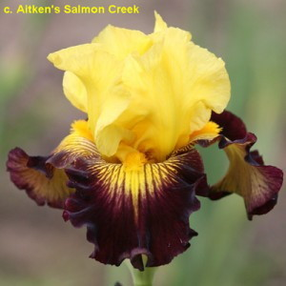
'Snapshot' (Thomas Johnson, R. 2007). Sdlg. TW 6C. TB, 32" (81 cm), M. S. yellow, red dots at base; style arms yellow; F. mahogany red, large yellow central area around yellow-orange beard; sweet fragrance. Honorable Mention 2010; Award of Merit 2012.
Hybridizer's Comment: 'Snapshot' may be short of stature but you won't overlook the powerful presence of its bright colors in your garden. Blazing yellow-gold standards continue as large sunbursts etched onto centers of mahogany-red falls. Mahogany veins radiate over sunbursts. Zingy gold beards amplify the sunburst effect. Growth is strong and robust. Stalks have two branches and 7 buds.
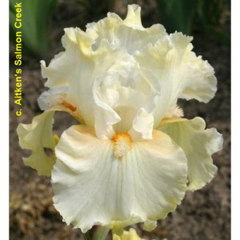
'Snow Lion' (Marky Smith, R. 2005). Sdlg. 00-24C. TB, 36" (91 cm), E. S. slightly smoked cream (RHS 158D) fading to near white; style arms cream, faint yellow crest and midrib; F. cream (158D), ruffled distal end more yellow (4C), apricot orange (168D) shoulders; beards cream, faint red- orange tips at end, strong red orange in throat; ruffled; pronounced spicy fragrance. HM 2010, AM 2012.
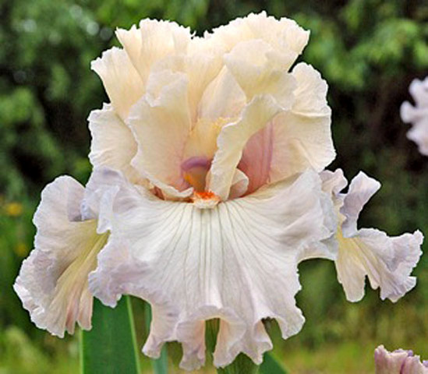
'Softly Waiting' (Barry Blyth, R. 2009). Sdlg. Q13-2. TB, 37” (94 cm), EM. Standards creamy peach to soft apricot; style arms slightly deeper than Standards giving inner glow; falls creamy peach, gentle lilac overlay; beards white tipped tangerine; slight sweet fragrance.
Hybridizer's Comment: Soft creamy peach-apricot standards. Style arms are slightly darker giving it an inner glow. Falls are similar with a soft overlay of gentle pastel lavender. Beards are soft tangerine on white. Very ruffled and flared with show branching. This is gorgeous and we have used it a lot in hybridizing. Not easy to pod but will set.
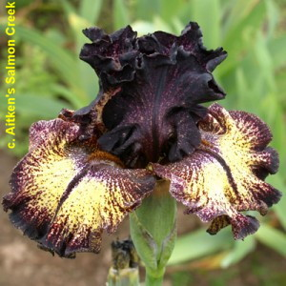
'Sorbonne' (Keith Keppel, R. 2008) Sdlg 02-81E TB ML 38" (97 cm), ML. S. blackish red-brown outer area, speckled with light yellow (M&P 9-E-2) in center; style arms dark red-brown; F. lemon gold (9-L-2) to cream ground center, sanded and speckled red brown toward edge and partial center line, distal margin blackish red-brown lightening to red purple (56-L-7) border, hafts near solid peppering on white ground; beards white tipped brown; plicata. Honorable Mention 2011.
Hybridizer's Comment: Intricate artwork. Standards blackish russet, with cream yellow ground barely showing in the central area. Arched falis open with bright lemon gold ground which ages to a softer creamy yellow. Dark burgundy maroon peppering and veining obscures the upper fall, continuing as a wide dotted margin, more solid at the distal tip. Beards inconspicuous, brown. Great color contrast gives garden impact.
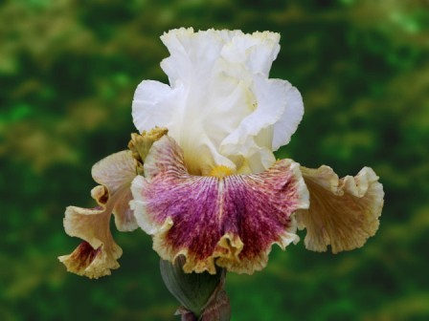
'Sordid Lives' (Thomas Johnson, R. 2009). Sdlg. TX56A. TB, 41” (104 cm), EM. Standards white, slight gold halo; style arms white, gold crests; falls blend from white to light yellow, centers wildly washed, mottled and dotted rose magenta shading to darker rose over centers, wide blended bands of off-white to yellow, hafts veined and sanded plum; beards gold; purple based foliage. HM 2011.
Hybridizer's Comment: Sordid Lives is as colorful and twisted as the movie by the same name. Pure-hearted white standards haloed in gold are in divine contrast to the raucously colored and blatantly ruffled falls. Falls blend from white to light yellow with centers wildly washed, mottled, and dotted rose magenta to darker rose over centers leaving wide blended bands of off-white to yellow. Hafts are veined and sanded plum. Add to it zany yellow gold beards and you have an unforgettable experience. Strong show stalks with 3-4 branches and 8-11 buds arise from clean, healthy purple base foliage.
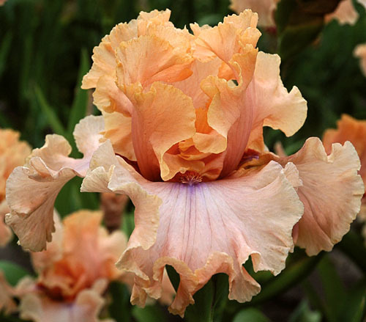
'Sunset Plaza' (Barry Blyth, R. 2008). Sdlg. O180-A. TB, 38" (97 cm), M. S. blended peach-apricot deepening toward apricot at edges; F. peach, opalescent overlay of pastel lavender deepening toward lavender signal below beard, hafts rosy brown; beards light burnt tangerine.
Hybridizer's Comment: One of the loveliest pastels we have raised to date. Gorgeous blended peach-apricot standards, tending more towards apricot on the outer. The falls are peach with an overlay of opalescent lavender, deepening towards a lavender blaze below the beards. Hafts are rosy brown and beards are light burnt tangerine. Lovely show branching and just a luscious pastel combination. Quite striking. Its pod parent, 'Fashionista' is a heavy rebloomer, though 'Sunset Plaza' shows no tendency to rebloom so far.
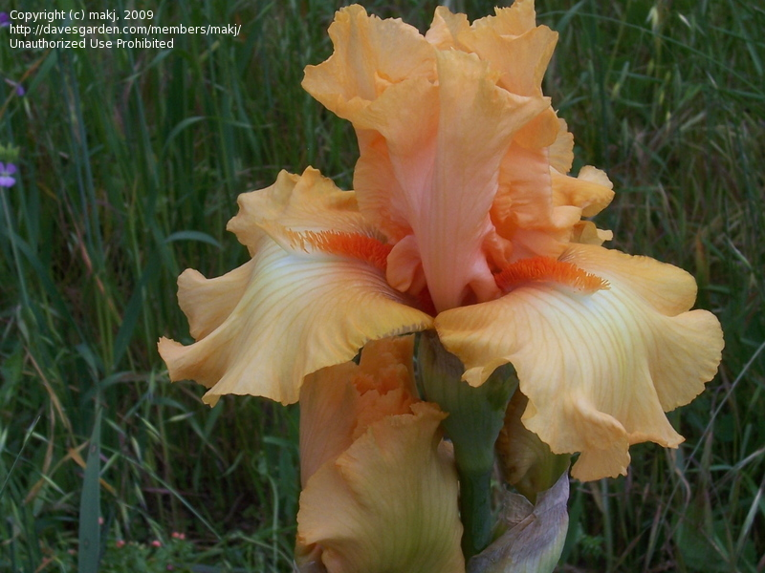
'Sunset Point' (George Sutton, R. 2001) Sdlg. H-170. TB, 37" (94 cm), ML. S. and style arms cadmium orange (RHS 23C); F. paler cadmium orange (23D), veined and edged darker (23C); beards tangerine, orange at end, with apricot horn; ruffled; slight sweet fragrance.
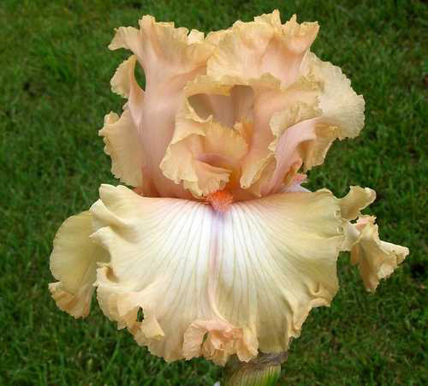
'Sweet Latte' (George Sutton, R. 2009). Sdlg. V-333-A. TB, 37” (94 cm), EML. Standards and style arms pale salmon blushed pink (RHS 27A); falls center creamy salmon, 1" edge of (27A); beards coral, blue at end; ruffled, moderately laced; slight musky fragrance.
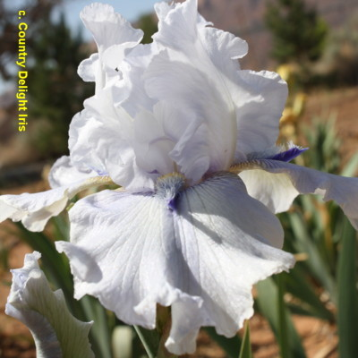
'Ty Blue' (Tom Burseen, R. 1999). Sdlg. 95-266D. TB, 35" (89 cm), Medium season Bloomer. Ruffled pale lavender, F. sometimes splotched violet; beards white, hairs tipped tangerine, purple horn; flared; sweet fragrance.
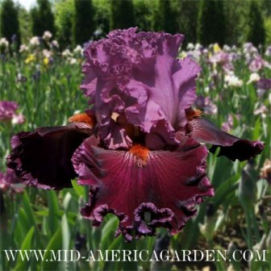
'Up In Flames' (Thomas Johnson, R. 2010) Sdlg. Ty67A. TB, 37" (94 cm), M. S. hot pink-rose; style arms buff; F. dark garnet, pink rose edges, subdued white veins around smoldering orange-red beards, plush, velvety; sweet fragrance. HM 2012.
Hybridizer's Comment: Temperatures rise and hot embers begin to glow until it goes Up in Flames. It's hot, hot, hot! Highly ruffled and laced standards and narrow rims around falls are hot pinkish rose. Plush, velvety falls are dark garnet. Smoldering orange-red beards are highlighted by subdued rose white veins surrounding them. Nicely branched stalks with about 7 buds.
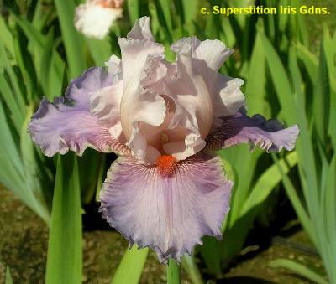
'Valentine Romance' (Walter Moores, R. 2007). Sdlg. 01-14-C. TB, 34-36" (86-91 cm), Medium season Bloomer.
S. light creamy pink; style arms light beige, darker in throat; F. medium mauve-orchid lightly rimmed beige, darker mauve-orchid center stripe, white lines at red orange beards; ruffled; pronounced sweet fragrance.
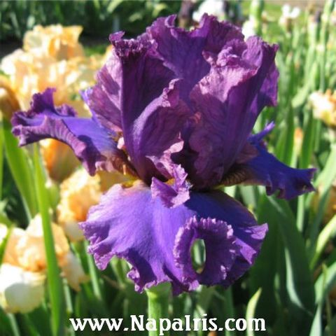
'Yuppy Puppy' (Tom Burseen, registered 2007). Seedling 02-61A. TB, height 36" (91 cm), mid season bloom. Standards and style arms violet (RHS 83D) washed over brown base; falls violet blue (94A), lighter edges; beards brown, violet blue (90C) tattered flounces; flared, ruffled; pronounced sweet fragrance. Honorable Mention 2012.
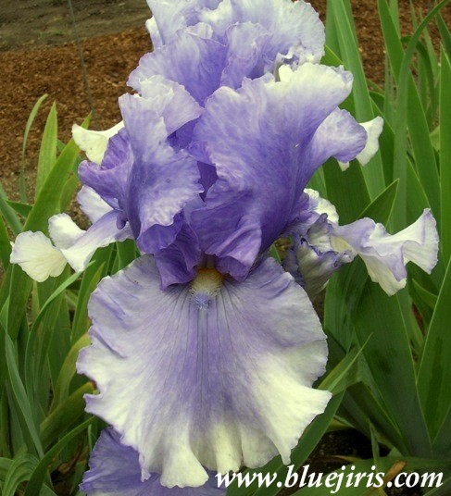
'Eagle's Spirit' (George Sutton, R. 2003). Sdlg. J-75. TB, 36" (91 cm), ML & RE. S. and style arms bluebird blue (RHS 94A), S. edge lighter; F. butterfly blue (near 106C), center washed bluebird blue, dark blue 1/4" wide line 3/4 way down; beards bluebird blue, bluebird blue horn; ruffled; slight sweet fragrance.

Louisiana Iris

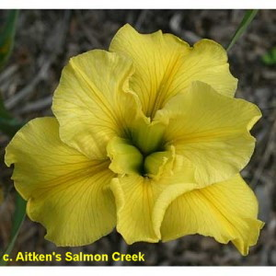
'Dossier' (Mary Dunn by Joseph Ghio, R. 1999). Sdlg. L248-11. LA, 36" (91 cm), ML. Pure yellow; style arms green.

